String manipulation Learning

Starts with
- STRING.startswith(“w”) (returns 1 or 0)

Multiply
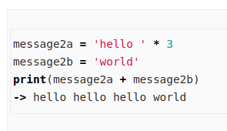

Find
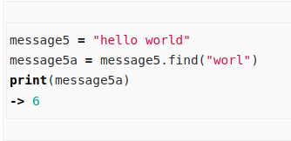

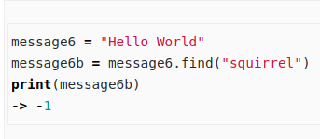

Lower Case
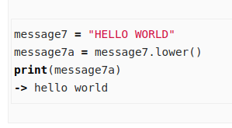

The opposite effect, raising characters to upper case, can be achieved by changing .lower() to .upper().

Replace
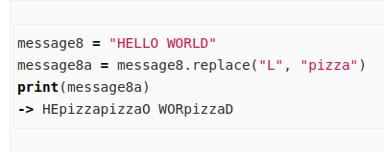

Slice
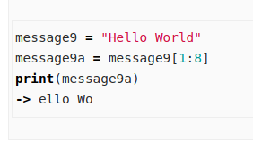

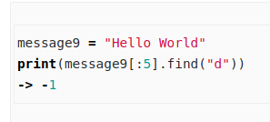

Escape Sequences
What do you do when you need to include quotation marks within a string?
